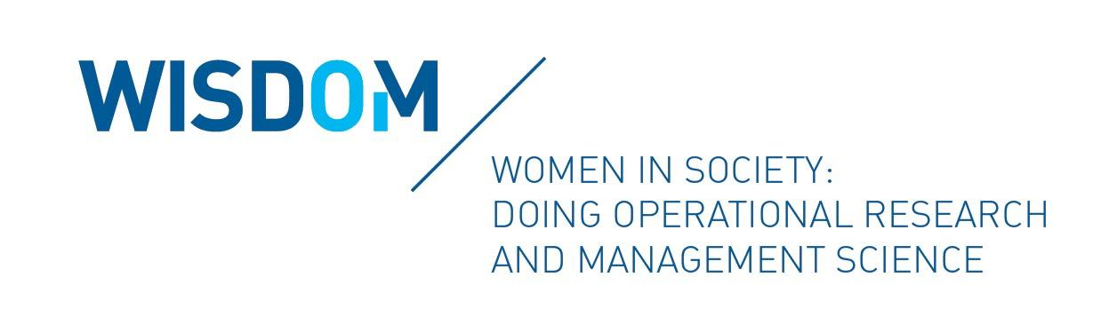
YoungWomen4OR
WISDOM (Women in Society: Doing Operational Research and Management Science) is a forum within the EURO (The Association of European Operational Research Societies) that aims to support, empower, and encourage the participation of all genders in Operations Research and Management Science (shortly OR). One of the goals of WISDOM is to promote championing, networking, and mentoring, particularly of women at the early stages of their career in OR.

In light of this goal, we would like to bring your attention to the 2021 call of the initiative YoungWomen4OR. This initiative aims to introduce to our community emerging young women working in OR, either in academia or in the industry. The WISDOM Forum will promote selected individuals by spotlighting their work through EURO channels and providing networking and mentoring opportunities. All young women working in OR are strongly encouraged to participate.

Eligibility:

- Early career female researchers/practitioners (at most 3 years after Ph.D.) or Ph.D. students in their last year of study in the field of OR;
- Member of a EURO national association.

Program Details and Benefits:

- WISDOM will select 12 individuals each year in order to advocate them by publishing their research profile on the WISDOM webpage and through EURO social media.
- Selected individuals will be invited to present their work or research proposals at the EURO-k Conference in the YoungWomen4OR Stream.
- Opportunities to meet with WISDOM members and other senior researchers within EURO will be created.

Selection:

The selection process will take into account the information provided in the application including the future project plans of the candidates. As far as possible, a fair representation of all the countries within the EURO association will be pursued. Selected candidates will be informed at the beginning of November 2021.

Jury:

The Selection Jury consists of the following WISDOM’s members: Ana Barbosa-Povoa (Portugal), Renata Mansini (Italy), Sibel Salman (Turkey).

Application deadlines:

The opening for the candidates’ application submission will be September 15th, 2021.

Candidates are invited to fill the application form by October 15th, 2021.

Contacts:

For further information, please send an e-mail to YoungWomen4OR@euro-online.org.

